AAE 334 Lab

Prelab

Problem (2)

XFLR5 results

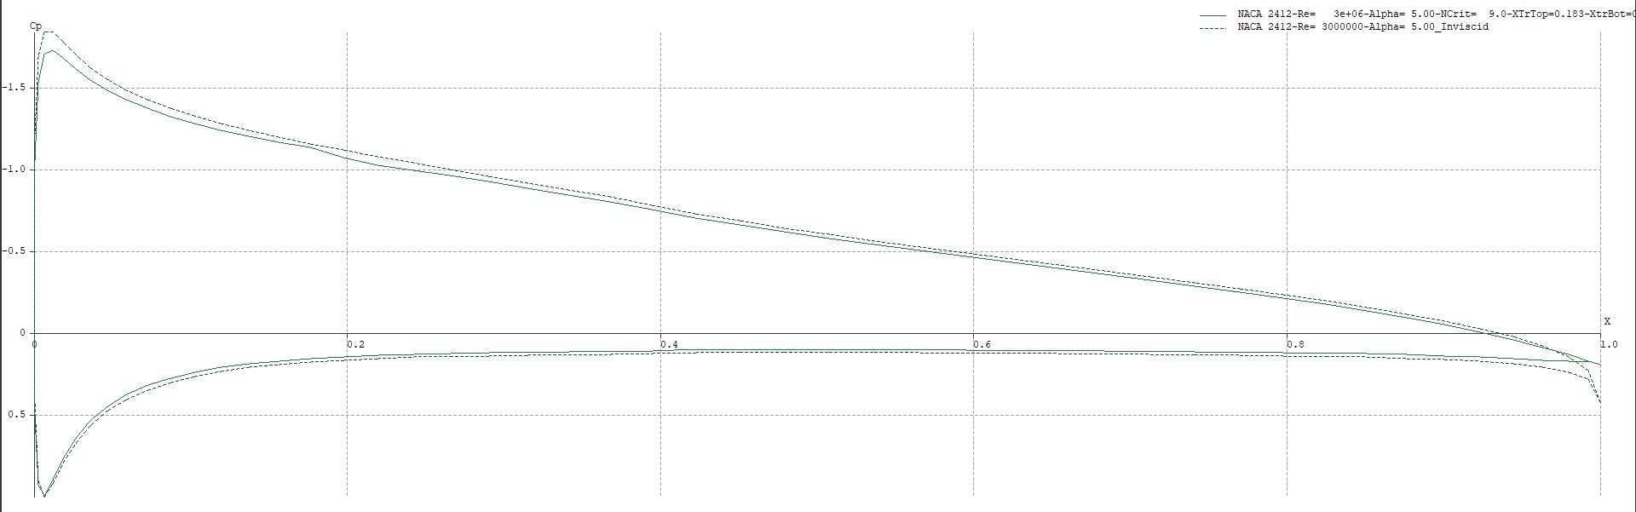

The inviscid pressure distribution has a larger magnitude throughout the airfoil compared to the viscous condition.